Steps to add Prettier

**Step1: Install Prettier**

Open extensions tab in VS code, search for “Prettier - Code formatter” and install.

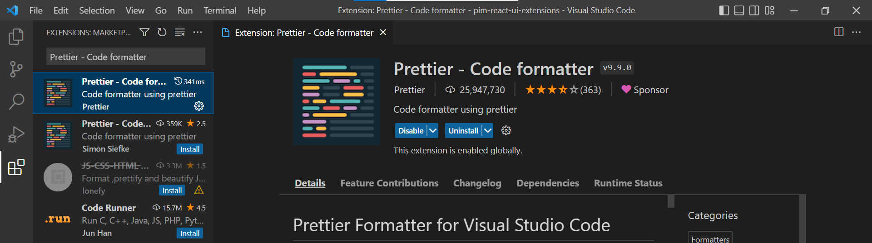

**Step2: Add settings to user Settings.json file**

Open command palette(cntrl + p), search for “>user settings”

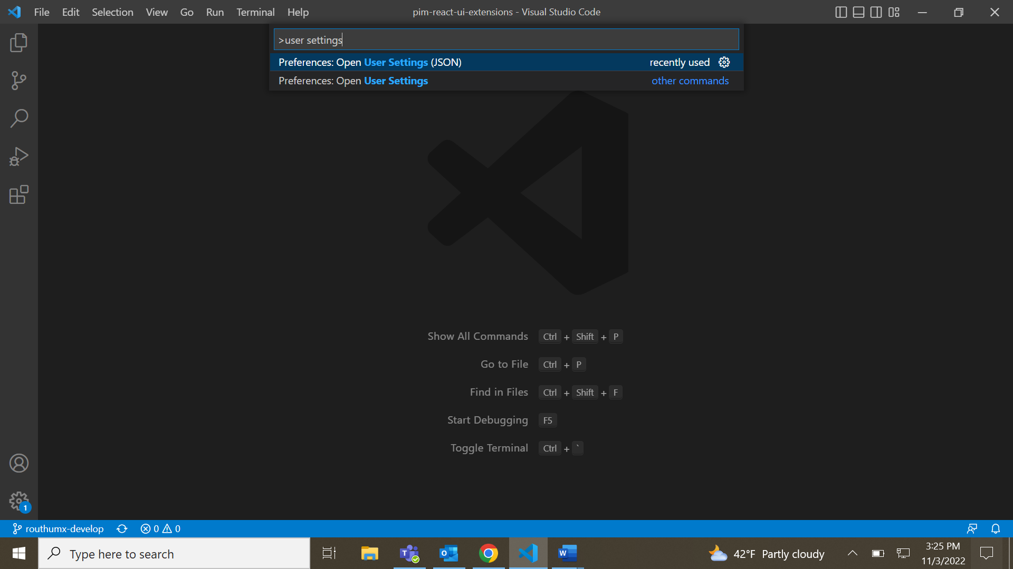

And, add below JSON for making prettier as editor’s default formatter and formatting file on save respectively.

{

"editor.defaultFormatter": "esbenp.prettier-vscode",

  "editor.formatOnSave": true

}

**Step 3: Add “.prettierrc” file in root folder of project.**

This is customized options JSON file for formatting. (Do Not modify this without approval)

**Reference:**

What is Prettier? - <https://prettier.io/docs/en/index.html>

Configuring Options - <https://prettier.io/docs/en/options.html>